September 26, 2025

To: Canterbury Townhomes Subdivision
Subject: Roadway Improvements – Asphalt Milling and Paving

As part of the ongoing infrastructure improvements in your subdivision, milling (removal) of the existing asphalt pavement is scheduled to begin on Tuesday, September 30, 2025, and is estimated to be completed in two (2 days), weather permitting. This work is crucial before paving a new asphalt riding surface. Once milling is completed, the contractor will be patching the base of the road to address failing areas. The next step will be paving the asphalt surface, which will take place in the days after the milling and patching.
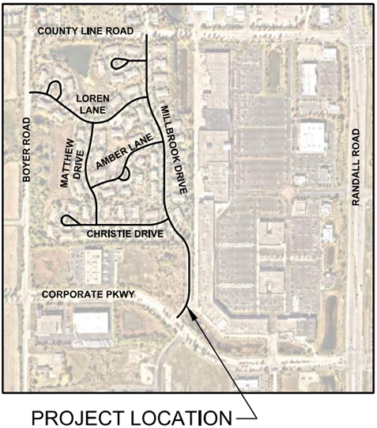
🚧 What to Expect
- No street parking is allowed between 7:00 AM to 6:00 PM on streets where work is to be performed.
- Active construction site with heavy machinery and trucks throughout the subdivision.
- Increased noise levels and temporary traffic disruptions may occur.
- Brief driveway access interruptions as crews work past individual homes. Please communicate with the on-site staff. They are there to help.

⚠️ Safety Reminders
- Please slow down and drive with caution for your safety and the safety of the workers.
- Obey all posted signs and follow flaggers’ directions.
- Watch for workers, equipment, and trucks entering and exiting the roadway.

📱 Stay Updated - If you have any questions, please contact:
- Raz Calin – Resident Engineer at (847) 533 3013 or rcalin@cbbel.com
- Download the "Algonquin Fix It" app or visit our website/social media for real-time updates.
Thank you again for your patience and cooperation. With your support, this project will enhance the longevity and safety of your neighborhood and streets.

Sincerely,

Clifton V. Ganek, P.E.
Village Engineer

For project updates, residents are encouraged to sign up for construction updates by scanning the QR code below.


